**Name(s):** Theodoros Mamalis

**Netid(s):** mamalis2

**Mean Reward Reached :** 11.9 (episode 2051)

**Uploaded Saved Double DQN Model on Compass :** Yes

**Uploaded your Agent.py and Agent_double.py file on Compass :** Yes

**Plot of Mean Evaluation Reward for DQN:** 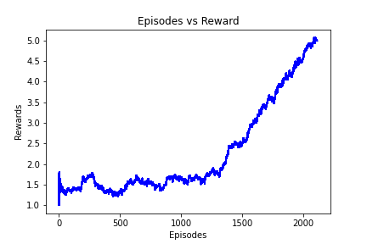

**Plot of Mean Evaluation Reward for Double DQN (please run both plots for the same number of episodes):** 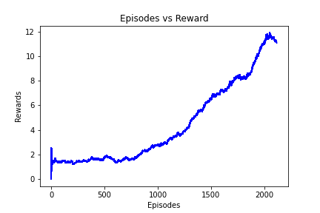

**Provide a few sentences of analysis between the differences between DQN and Double DQN:**

The Double DQN algorithm reaches higher rewards in fewer episodes; after 2000 episodes, Double DQN reached a reward close to 12 whereas DQN reached a reward close to 5. Even if there is a chance that when running these models, during some runs the learning will be inhibited by problems such as slow reward increase, or reward decreasing rapidly after some episodes, this happens less often for Double DQN.

**Extra Credit:**

1. What games did you apply the extra credit to?
2. What other algorithm did you use? Explain and cite all your sources. Any issues you got in training your new algorithm.